An Internship Report
Of
NetSage AI: AI Deployment Automation for Cisco Network Troubleshooting
Submitted
To
School of Computer Science and Engineering
IILM University, Greater Noida, U.P.

In partial fulfilment of the requirement of degree of
B-Tech (CSE)



By

Roll Number of Student:- 2410030089
Name of Student: Mohammad Amaan Aslam

Batch: 2026-27

CANDIDATE'S DECLARATION
I, Mohammad Amaan Aslam, do hereby declare that the internship report titled “NetSage AI: AI Deployment & Automation for Cisco Network Troubleshooting” has been completed by me to fulfil the requirement for the award of the degree of Bachelor of Technology in Computer Science and Engineering. All the references have been quoted and I have not taken as such any material from any other source. I Confirm that this report is my own and has not been submitted to any other institute for any degree/diploma requirement, and further I shall be solely responsible for any kind of copyright violation in this regard.
Signature:-

Student Name: MOHAMMAD AMAAN ASLAM

Roll No.: 2410030089

ACKNOWLEDGEMENT
I am using this opportunity to express my gratitude to everyone who supported me throughout this program. I am thankful for their inspiring guidance, invaluably constructive criticism, and friendly advice during this work. I am sincerely grateful to them for sharing their truthful and illuminating views on a number of issues related to this work.
I would like to express my heartiest gratitude to Cisco Networking Academy for providing the structured virtual internship platform and tools to build hands-on exposure in AI deployment, network automation, and deterministic diagnostic modeling.
I am deeply thankful to my instructor, Prof. Swati Vashisht, for her invaluable guidance and mentorship throughout the coursework. I am also thankful to my institute, IILM University, and the faculty of the School of Computer Science and Engineering for their continuous support and encouragement.

I express my gratitude to my parents for their blessings.
Signature:

Student Name: MOHAMMAD AMAAN ASLAM

Roll No.: 2410030089

TABLE OF CONTENTS
1. Candidate's Declaration i
2. Acknowledgement ii
3. Internship Completion Certificate -
4. Project Description 1
4.1 Introduction 1
4.2 Organization Profile 2
4.3 Problem Statement 3
4.4 Project Objectives 3
4.5 Scope of the Project 4
4.6 Technologies and Tools Used 4
4.7 System Architecture 5
4.8 Methodology 6
4.9 Expected Outcomes 7
4.10 Certificates of Completion and Communication Proof 8
5. Bibliography/References 9

3. INTERNSHIP COMPLETION CERTIFICATE
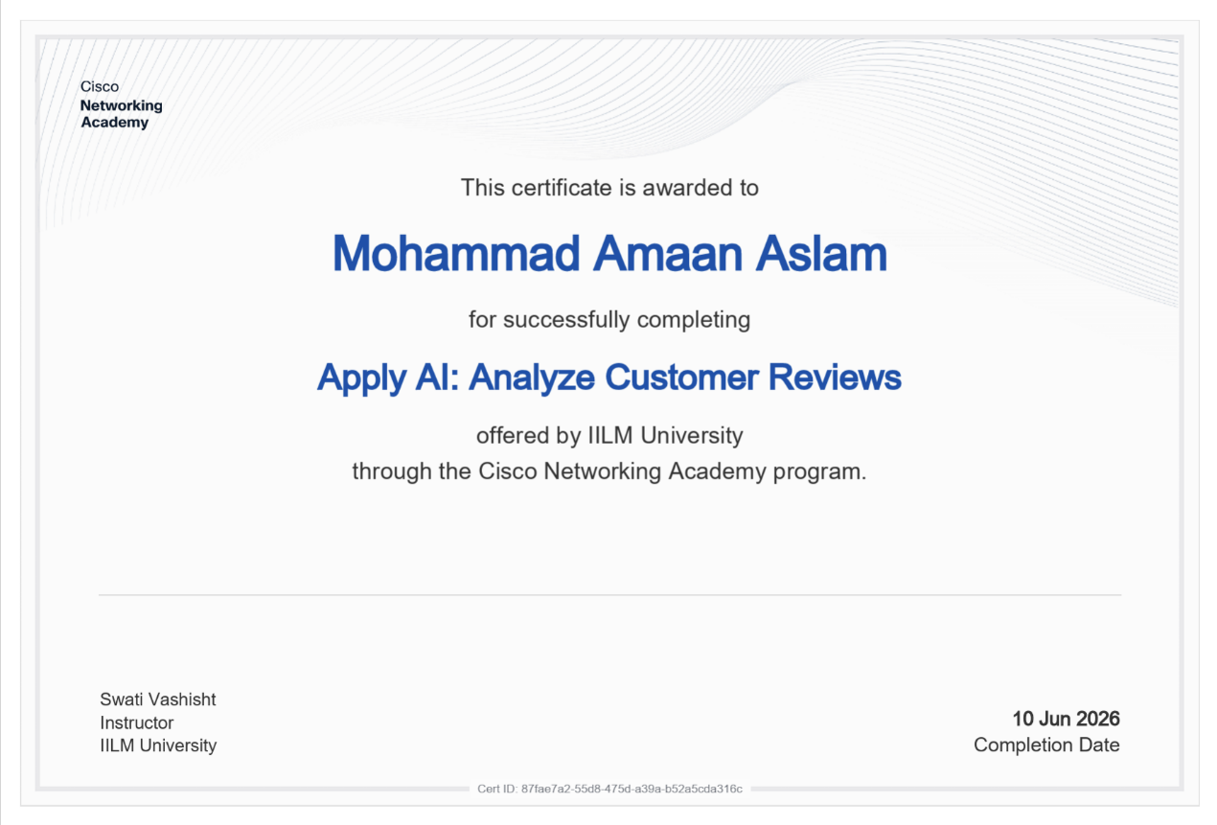

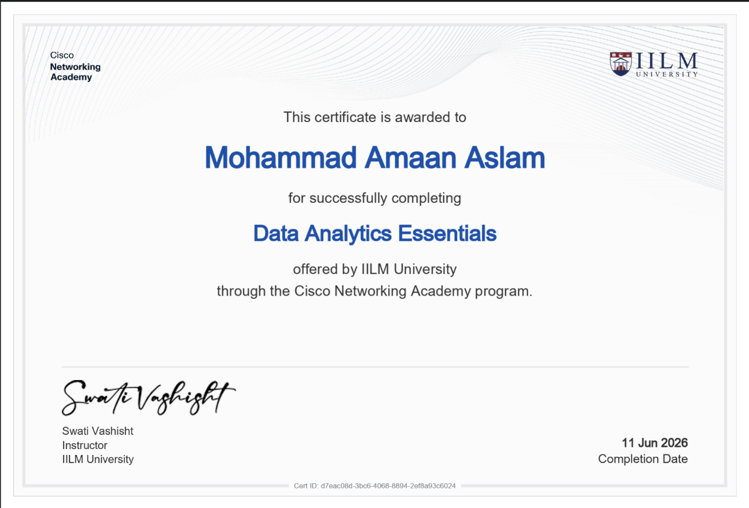

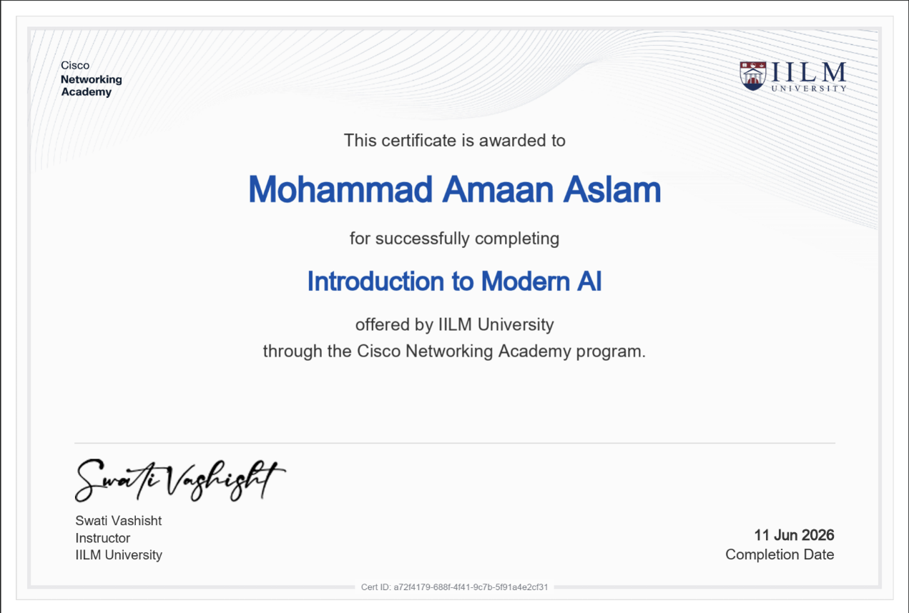

4. PROJECT DESCRIPTION

4.1 Introduction
This report presents a detailed account of the Cisco Virtual Internship Project titled Net Sage AI: AI Deployment & Automation for Cisco Network Troubleshooting. The project was completed under the mentorship of Prof. Swati Vashisht as part of the B-Tech (CSE) degree requirements at IILM University, Greater Noida. Net Sage AI is an intelligent troubleshooting copilot designed for Cisco Packet Tracer and enterprise lab environments. It bridges the gap between raw CLI symptoms and accurate root-cause identification by evaluating show-command outputs, topology notes, and error logs to provide actionable, evidence-backed fixes while maintaining mandatory human oversight.
4.2 Organization Profile
Cisco Networking Academy is a global IT and cybersecurity education program designed to empower learners with industry-relevant digital skills. Partnering with academic institutions like IILM University, the academy provides structured, hands-on curricula and virtual internship opportunities in emerging technologies, including Data Analytics, Modern AI, Network Automation, and Cybersecurity.
4.3 Problem Statement
Junior network engineers often know individual CLI commands but struggle to connect symptoms to the actual root cause when troubleshooting multi-layer networks. When a host receives an IP address but cannot reach a server, diagnosing whether the issue stems from VLAN tagging, gateway mismatches, DHCP relay failures, ACL blocks, NAT misconfigurations, or routing table drops is difficult. Furthermore, fully autonomous AI models present severe operational risks if allowed to execute unverified CLI changes on live infrastructure. Net Sage AI addresses this by providing structured AI recommendations backed by a mandatory human-in-the-loop approval mechanism.
  - Project Objectives
- To construct a dataset of at least 30 real-world Cisco Packet Tracer lab cases covering Layer 1 through Layer 7 network faults.
- To design structured system prompts and few-shot templates forcing LLMs to return strict JSON outputs with root cause, confidence, CLI evidence, next verification command, and CLI fix steps.
- To build a deterministic Python rule checker script (rule_checker.py) that flags basic configuration errors (e.g., shutdown ports, duplicate IPs, timer mismatches) prior to AI inference.
- To design an interactive Executive Dashboard displaying AI agreement rates, human decision breakdowns, and fault distribution across OSI layers.
- To maintain a Responsible AI Audit Log documenting at least 5 scenarios where human reviewers edited or rejected AI diagnoses to prevent erroneous configuration changes.
  - Scope of the Project
The scope encompasses the end-to-end AI deployment pipeline for network troubleshooting—from constructing 30 multi-layer Cisco lab cases to developing deterministic Python validation engines, structuring prompt libraries, building Excel analytical dashboards, and enforcing human safety oversight.
The project covers VLANs, 802.1Q trunking, DHCP relays, static routing, RIPv2, OSPF, EIGRP, NAT/PAT, ACLs, STP, HSRP, EtherChannel, and RADIUS/Wireless setups.
  - Technologies and Tools Used
- Simulation & Domain Tools: Cisco Packet Tracer, Cisco IOS CLI
- Programming & Rule Automation: Python 3.8+ (Pandas, OpenPyXL, Regular Expressions)
- AI & LLM Architectures: Generative AI Systems (Gemini / ChatGPT), Prompt Engineering Templates
- Dashboard &Analytics: Microsoft Excel (KPI Blocks, Pivot Analytics, Embedded Pie &amp; Bar Charts)
- Documentation & Protocols: JSON Schema Enforcement, Responsible AI Audit Framework
  - System Architecture
The NetSage AI deployment pipeline consists of five interconnected layers:
1. Input Data Layer: Captures raw Packet Tracer symptoms, topology notes, and CLI show command outputs.
2. Deterministic Rule Checker Layer: Python script parses CLI text for immediate pattern matching (e.g.,shutdown interfaces, err-disabled ports, duplicate IPs).
3. AI Prompt Engine Layer: Route symptoms and CLI evidence into prompt templates enforcing JSON responses grounded in quoted evidence.
4. Human Review Dashboard Layer: Presents AI findings to a human engineer with options to Accept, Edit, or Reject.
5. Audit &amp; Execution Layer: Logs human overrides into the Responsible AI audit log and executes verified CLI fixes.
4.8 Methodology
The methodology followed a 6-step lifecycle:
(1) Scenario Data Collection across 30 lab cases;
(2) Prompt Engineering with strict JSON schema and few-shot examples;
(3) Python Scripting for deterministic rule validation;
(4) AI Diagnosis Execution and output comparison against ground truth;
(5) Human Oversight Implementation where every diagnosis was audited;
(6) Executive Dashboard & Audit Logging.
4.9 Expected Outcomes
The project achieved an 83.3% AI-to-human agreement rate across 30 cases. 25 cases were accepted directly, 2 were edited, and 3 were rejected. The deterministic Python rule checker flagged basic L1-L3 configuration errors across 10 cases, ensuring fast pre-AI validation.
4.10 Certificates of Completion and Communication Proof
Case ID | Symptom | Human Decision | Corrected Root Cause
NET-005 | Web page won't load; public IP ping works. | Rejected | Incorrect DNS server IP configured on client PC (192.168.1.250).
NET-007 | Guest Wi-Fi can reach internal corporate server. | Rejected | ACL BLOCK_GUEST permits traffic and is not bound to the subinterface.
NET-013 | SSH access denied from admin workstation. | Edited | VTY ACL 10 restricts access to the wrong host (.10 instead of .50).
NET-020 | HSRP fails to pre-empt back to R1. | Edited | Missing standby 1 preempt command on Router R1.
NET-027 | Dynamic NAT pool exhausted for staff. | Rejected | Missing overload keyword in NAT source command (PAT).

5. BIBLIOGRAPHY/REFERENCES
• Cisco Networking Academy & IILM University. Certificate of Course Completion – Data Analytics Essentials. Certificate ID:d7eac08d-3bc6-4068-8894-2ef8a93c6024, Issued on June 11, 2026.
• Cisco Networking Academy & IILM University. Certificate of Course Completion – Introduction to Modern AI. Certificate ID:a72f4179-688f-4f41-9c7b-5f91a4e2cf31, Issued on June 11, 2026.
• Cisco Networking Academy & IILM University. Certificate of Course Completion – Apply AI: Analyze Customer Reviews. Certificate ID:87fae7a2-55d8-475d-a39a-b52a5cda316c, Issued on June 10, 2026.
• Cisco Systems, Inc. Cisco Virtual Internship Project 2: NetSage AI – Applied AI + Network Troubleshooting Problem Statement & Guidelines. Cisco Networking Academy Platform, 2026.
• Cisco Networking Academy. Cisco Packet Tracer CLI Reference & Command Documentation. Available at: https://www.netacad.com/
• Python Software Foundation. Python Documentation and Regex Engine Guidelines. Available at: https://docs.python.org/3/
• OpenAI. OpenAI API Documentation and Large Language Model Prompting Guides. Available at: https://platform.openai.com/docs/

